**Project 5 Part 3 Canny Edge Detection Complete**

Name: Aditya Vasantharao Period: 3 Date: 1/27/22

Is your lab name l053?(lowercase L followed by digits 053) Yes

**Did you test your code on a school terminal using c++11?** Yes

Does your main method call only part3()? Yes

Did you create a gray image? Yes

Did you apply the Sobell operator? Yes

Did you apply a double threshold? Yes

Did you apply non-max suppression? Yes

Did you test using command line arguments? Yes

Paste here **5 clear pictures** of the initial picture (image.ppm0, the grey image (imageg.ppm), the image obtained after applying hysteresis & double threshold (image1.ppm), the image you obtained after applying non-maximum suppression (image2.ppm), the image obtained after applying both (imagef.ppm):

Image:

Imageg:

Image1:

Image2:

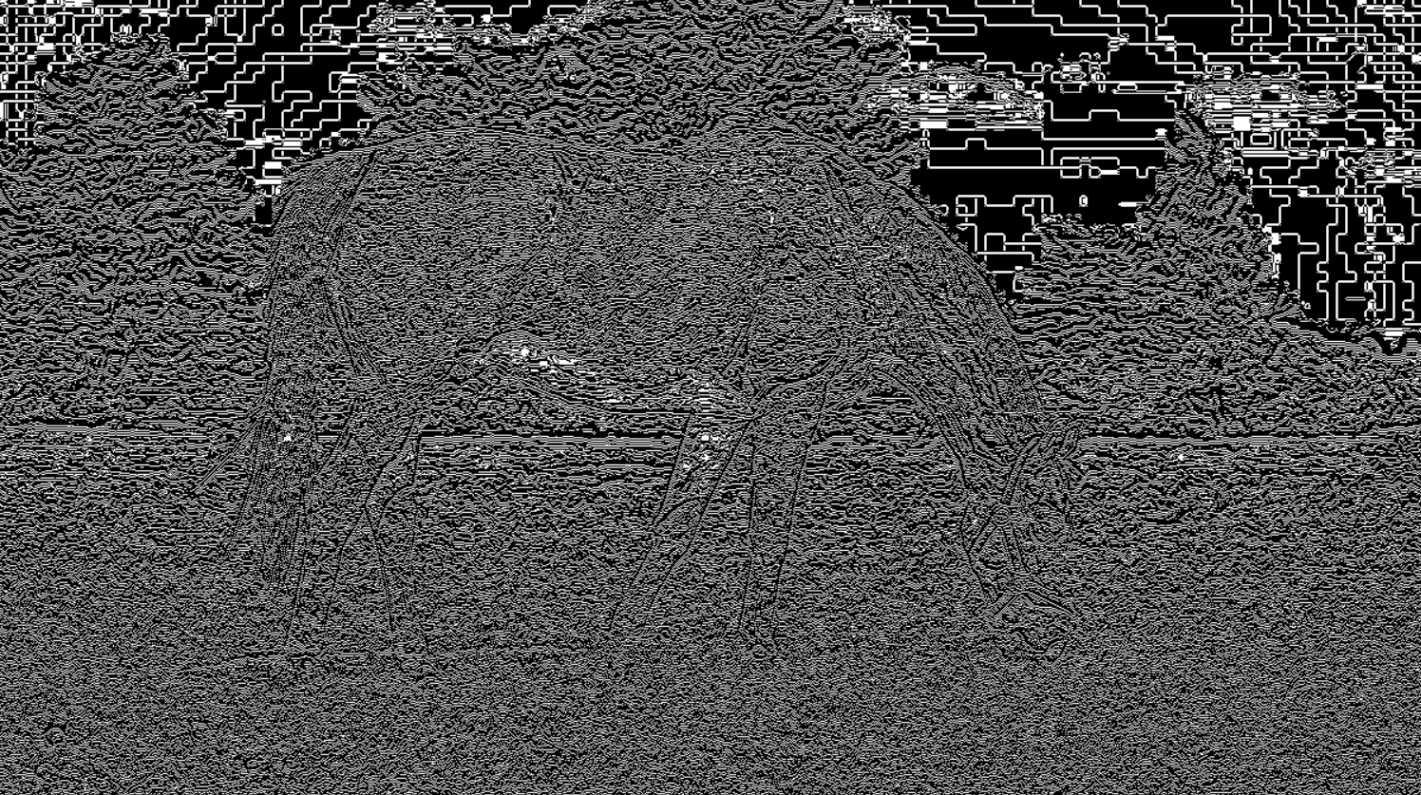

Imagef:

